## Installing and Configuring Oracle Server Software

Because system configurations and individual company standards vary, use this section as a checklist instead of step-by-step instructions. Please contact support for specific configuration questions. These instructions are for installing Oracle on a computer running the Windows Server operating system. See the *Oracle Linux Installation and Configuration* guide for instructions on installing Oracle on a computer running Linux.



* We recommend that you set up the Windows server network before installing Oracle.
* Oracle recommends a static IP address.
* You should install the Oracle server software using the local computer administrator account. Do not use a domain user or a user in the local Administrator group. For more information, refer to the Oracle installation documentation.
* All domain verified user names and passwords must use ASCII7/English characters. Oracle does not support non-ASCII / English characters in domain user names or passwords and will not work. In addition, do not use the @ character in an Oracle password. This limitation applies only to Oracle, not Hexagon PPM.

Oracle Instances

If one server hosts the databases of several products, we recommend that each product database be a separate instance, each of which can host multiple plants.

The advantage of placing each product database in its own instance is that only the affected application will be off-line during backup, performance tuning, and other database maintenance activities. Additionally, global tuning parameters that apply to one instance can be tailored to the specific product requirements.

According to Oracle documentation, the only limit to the number of instances you can have on any machine is the availability of resources. However, the number of instances on one database server should be minimized because each additional instance puts additional load on the server.

Each instance adds redundant tablespaces, rollback segments, background processes, and memory requirements for each System Global Area (SGA). For this reason, you should start by putting the database of one product for several plants into a single instance. Then, when the number of plants increases, or a plant becomes very large, consider separating the database into new instances, adding server memory, or even adding database servers.



* Oracle recommends that database activity on the database server consume no more than 60 percent of the available memory. Refer to your Oracle documentation for specific requirements.
* Do not use the @ character in any Oracle passwords.
* There are Oracle restrictions for the database global name and corresponding database link name (they are required to match). There are three known restrictions on global database names:
  1. No hyphens are allowed.
  2. The computer name cannot start with a number.
  3. There is a maximum of 30 characters for the name.
* After installing the Oracle server software, you must initialize the Oracle database using either [Initialize the Oracle Database](https://docs.hexagonppm.com/reader/XNI2thZWwpu_8XwBCfLFPQ/O8TinQo0cJd~p12sxuEkAA) or the [Initialize the Oracle Database with Minimum Access Privilege](https://docs.hexagonppm.com/reader/XNI2thZWwpu_8XwBCfLFPQ/YDxniKzgjLQ52wl5Cr7F1Q) procedures.
* The Molded Forms **Copy by Family** command should be run by a user with at least Project Administrator access on Oracle. This command will fail if you initialize the Oracle database with Minimum Access Privilege.

### Oracle Server Configuration

1. Log in as a user with administrator access to the server.
2. Turn off **Windows Firewall**. If this is not an option, please refer to the *Oracle Installation Guide* for information on the exceptions that must be put into place prior to installing Oracle on Windows.
3. In the **Folder Options** of Windows Explorer, clear the **Simple File Sharing** option.
   1. Open **Windows Explorer**.
   2. Press **ALT** and select **Tools**.
   3. Select **Folder Options**.
   4. Select the **View** tab.
   5. Scroll to the bottom and clear the **Use Sharing Wizard (Recommended)** option.
4. Click **OK**.

### Install and Configure Oracle Server Software

During installation of the database components, setup displays various dialog boxes that prompt you for information. We recommend that you refer to your Oracle documentation for specific instructions concerning the dialog boxes and wizard pages.

 All domain verified user names and passwords must use ASCII7/English characters. Oracle does not support non-ASCII / English characters in domain user names or passwords and will not work. In addition, do not use the @ character in an Oracle password. This limitation applies only to Oracle, not Hexagon PPM.

### Oracle 12c Server Installation

1. Log into the server as a local administrator.
2. Run setup.exe with administrator privileges.
3. On the **Configure Security Updates** page, enter the required values, and click **Next**.
4. On the **Download Software Updates** page, select **Skip software updates**, and click **Next**.
5. On the **Select Installation Option** page, select **Install database software** **only**, and click **Next**.
6. On the **Grid Installation Options** page, select **Single instance database installation**, and click **Next**.
7. On the **Select Product Languages** page, select your language, click **>>**, and then click **Next**.
8. On the **Specify Oracle Home User** page, select **Use Windows Built-in Account**. Click **Next**.

*Setup prompts you to confirm your selection.*

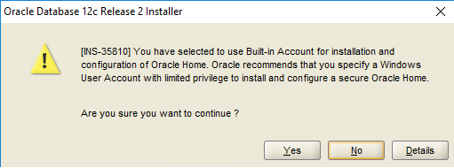

1. Click **Yes**.
2. On the **Installation Location** page, define the **Oracle base** and **Software location** folders. Click **Next**.
3. On the **Summary** page, click **Install**.
4. Click **Close** when the installation has completed.
5. Run these two commands from a "Run as administrator" command prompt. Replace <ORACLE_HOME> with the Oracle installation folder, usually C:\app\<oracle_user>. If the 32-bit and 64-bit versions of Oracle 12.2 are both installed on the server, then these commands must be run for each install.

**32-bit Install**

SET ORACLE_HOME=<ORACLE HOME>\product\12.2.0\x86

<ORACLE_HOME>\product\12.2.0\x86\odp.net\bin\4\OraProvCfg.exe /action:gac /providerpath:<ORACLE_HOME>\product\12.2.0\x86\odp.net\bin\4\Oracle.DataAccess.dll

**64-bit Install**

SET ORACLE_HOME=<ORACLE HOME>\product\12.2.0\x64

<ORACLE_HOME>\product\12.2.0\x64\odp.net\bin\4\OraProvCfg.exe /action:gac /providerpath:<ORACLE_HOME>\product\12.2.0\x64\odp.net\bin\4\Oracle.DataAccess.dll



* + The same command line commands must also be run on the Name Generator computer.
  + Run the commands again on any computer after installing Oracle patch 28810696.
  + Global Workshare does not work with Oracle July 2018 Interim Patch# 27937914 or Oracle October 2018 Interim Patch# 28574555 bundle patches on Oracle 12.2.0.1.

### Create the Oracle 12c Database

These steps guide you through the database creation process. You must log on to the server as a local administrator to create the Oracle database.

1. On the **Start** menu, open the Oracle**Database Configuration Assistant** wizard as an administrator.
2. On the **Database Operation** page, select **Create Database**, and click **Next**.

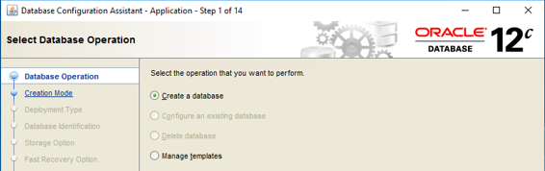

1. On the **Creation Mode** page, select **Advanced Mode**, and **click Next**.
2. On the **Database Template** page, select the **Custom Database** option, and click **Next**.

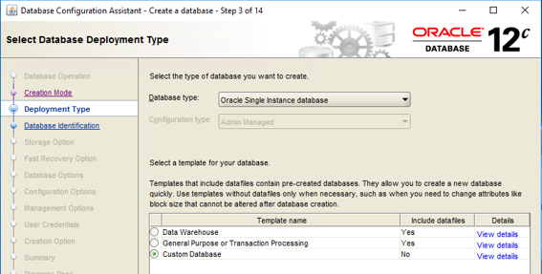

1. On the **Database Identification** page, enter the **Global Database Name** and the **SID** for the database. These names are generally identical and can be no longer than eight characters.

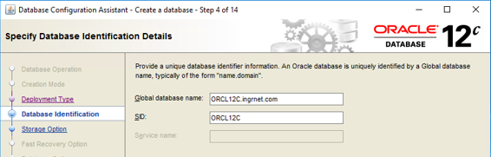

1. If you want to create a container database, select **Create As Container Database**.
2. Enter the **Global Database Name** and **SID**. Clear the **Create As Container Database** option. Smart 3D does not support pluggable databases. Click **Next**.

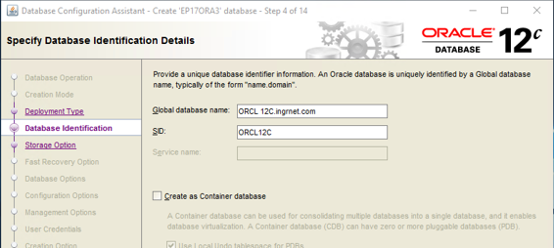

1. On the **Storage Locations** page, select **File System** and **Use Common Location for All Database Files**. Browse to and select the appropriate file location.

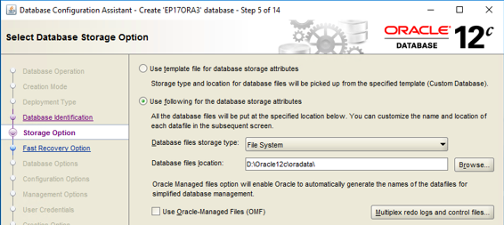

1. On the Fast Recovery page:
   * If the database will be not used in a Global Workshare Configuration, select **Specify Fast Recovery Area** in the **Recovery Configuration** screen, and click **Next**.
   * If the database will be used in a Global Workshare Configuration, select **Enable Archiving**, and click **Edit Archive Mode Parameters**.

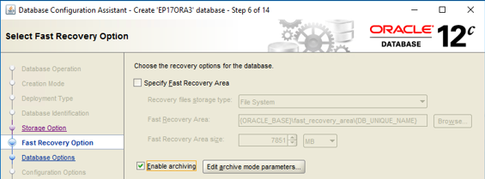

1. Select **Automatic Archiving** to specify the location of the archive log files. Click **OK**.

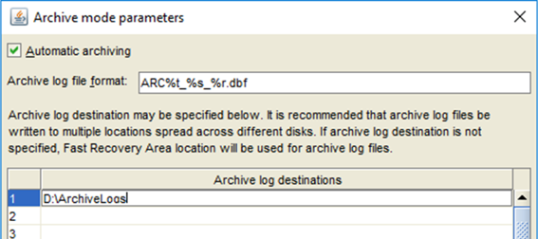

1. Click **Next**.
2. On the **Network Configuration** page, select **Create a New Listener**, and enter a name and port number. Click **Next**.

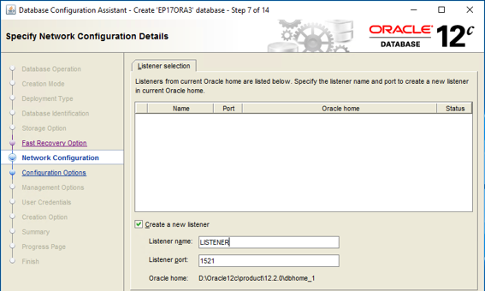

1. On the **Database Options** page, clear all database component selections under the **Database Components** tab. Click **Next**.

 All the database components are selected by default if you are creating a container instance. Leave them all selected if that is the case.

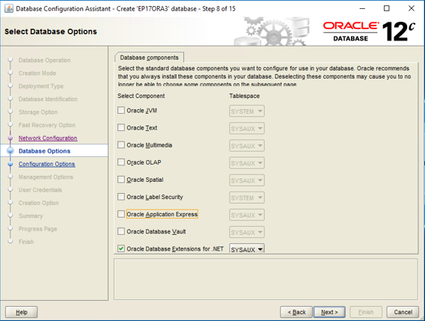

1. On the **Specify Configuration** page, select the **Memory** tab.
2. Select the **Typical Settings**option. The percentage of memory allowed for an instance of Oracle should not exceed 40%. If you have more than one Oracle instance on this server, the allocated memory should not exceed 40% of the system memory.

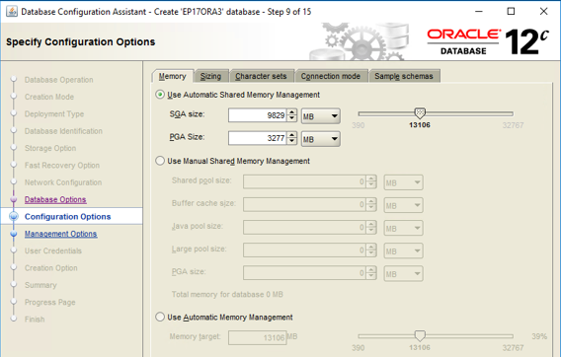

1. On the **Sizing** tab, configure the **Processes**option based on this formula.

Processes » (Maximum Number of Users * 10) + (Number of Oracle System Processes)

 The number of Oracle system processes can vary based on the number of background processes that are running. This number is a high estimate. Overestimate the number to ensure Oracle will only use the number of processes that the instance needs.

1. Select the **Character Sets** tab, and select the **Use Unicode (AL32UTF8)** option.



* + All Hexagon PPM products that participate in integration should set their encodings to **Use Unicode (AL32UTF8)** for the **Database Character Set** option, and to **AL16UTF16 - Unicode UTF-16 Universal character set** for the**National Character Set** option.
  + For more information about the Character Set options, see your Oracle installation documentation.

1. Select the **Connection Mode** tab, and select **Dedicated Server Mode**.
2. Click **Next**.
3. On the **Management Options** page, click **Next**without changing the default selections. **Configure Enterprise Manager (EM) Database Express** and port 5500 are the default options.

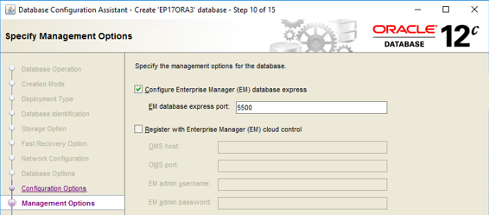

1. On the **Database Credentials** page, select a security option and provide the appropriate information. Click **Next**.

 Do not use the @ character in the password.

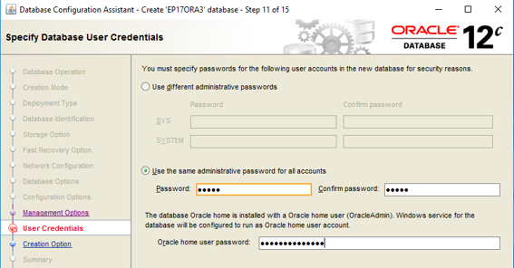

1. On the **Database Creation** page, click **All Initialization Parameters**, and select **Show advanced parameters**.

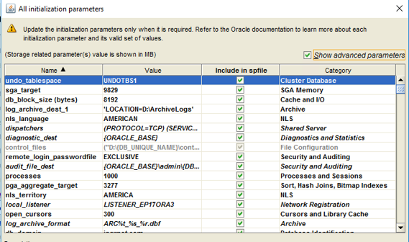

1. Change the parameters values as shown. Make sure a check mark () is displayed in the **Override Default** column.

db_files 1000  
distributed_lock_timeout 180  
open_cursors 3000  
os_authent_prefix ""  
processes 1000  
session_cached_cursors 200  
undo_retention 3600

1. Select **Close**.
2. On the **Creation Options** page, click **Customize Storage Locations**.

 The control files should be divided among multiple physical hard drives. This file is needed by the database to start.

1. Verify that the path in the **Tablespaces** folder is correct for **SYSAUX**, **SYSTEM**, **TEMP**, **UNDOTBS1**, and **USERS**.

 The information in the **Datafiles** and **Redo Log Groups** folders can retain the default settings as long as the folder path does not need updating.

1. Create an additional Redo log file, and set the Redo log file size for each group to 500 MB.

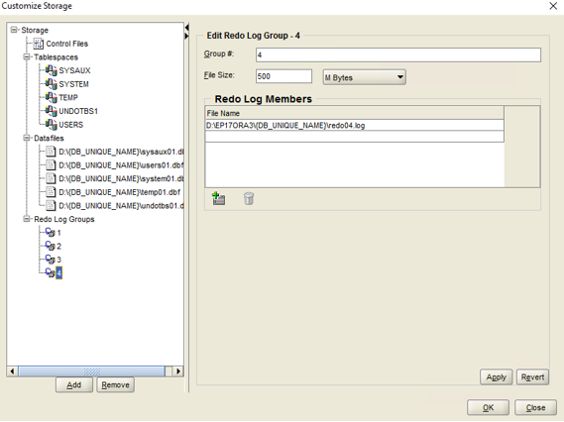

 The **Creation Options** page allows you to save your database configuration as a template file, and also allows you to generate database creation scripts.

 Not every setting is preserved in the template file. If you re-use template files, check the parameters carefully to verify that the settings are correct.

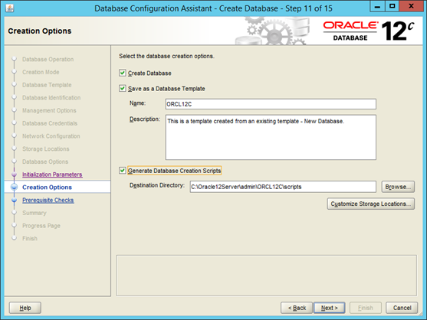

1. Click **Next**.
2. Click **Finish**.

 The first 15% of the creation process validates the configuration settings. After the first 15% of the process has successfully passed, the database creation succeeds without any errors.

1. After the **Database Configuration Assistant** completes the database creation, click **Close**.

### Configure Oracle Net Services

With regard to the steps below, all of the Oracle service names that will participate in the workshare must be configured as a local net service at each location. For example, on the host server you must add the Oracle service name for each satellite server that is participating in the workshare. On each satellite server that is participating in the workshare, you must add the Oracle service name for the host.

1. Start the **Oracle Net Configuration Assistant**.
2. On the **Welcome** page, select **Local Net Service Name configuration**, and then click **Next**.
3. Click **Add** on the **Net Service Name Configuration** page, and then click **Next**.

 The **Service Name** cannot contain a period.

1. On the **Service Name** page, enter the name that identifies the database service in the **Service Name** box that you want to add, and then click **Next**.

 The service name is the Oracle database instance name, not the database server computer name.

1. Select the **TCP** protocol, and then click **Next**.
2. Type the computer name of the database server in the **Host name** box. You can also enter the TCP/IP address.
3. Click **Next**.
4. Select **Yes, perform a test** to perform the connection test, and then click **Next**.
5. Click **Change Login**, and enter the system user name and password to use to test this connection.
6. If the test is successful, then click **Next**.
7. Enter the **Net Service** name. This name becomes the alias by which the Oracle database server is identified.
8. Click **No** when asked if you want to configure another service, and then finish the wizard.

When you complete the step above, select the option to perform a test of the net service name information. During a test, Oracle **Net Configuration Assistant** attempts to contact the remote database service, establishes a connection, and then ends contact.



* Repeat this procedure until all of the Oracle service names participating in the Workshare have been configured as a local net service.
* For more information about using Oracle **Net Configuration Assistant**, see the Oracle Database Net Services Administrator's Guide delivered with the Oracle database software.

### Initialize the Oracle Database

After the Oracle server software is installed and configured (that is, you can connect from a client to the Oracle database), you must configure the database to run with Smart 3D software.

The Smart 3D Reference Data Installation (see [Reference Data Setup](https://docs.hexagonppm.com/reader/XNI2thZWwpu_8XwBCfLFPQ/XIRRXPYS1SkaZH8nDJC9mA)) delivers the following sample script files to the <*Product Folder*>\3DRefData\Tools\OracleScriptsToInitDB folder.

1. OracleScriptsToInitDB\SP3DUser_ROLES.SQL
2. OracleScriptsToInitDB\SP3DProjectAdminstrator_ROLES.SQL
3. OracleScriptsToInitDB\SP3DUser.SQL
4. OracleScriptsToInitDB\SP3DProjectAdministrator.SQL

These script files create the necessary schemas, users, and roles that are used to run the software on Oracle. The delivered script files, however, are only samples and must be edited to fit your server configurations.

 Existing scripts delivered in the OracleScriptsToInitDB folder create the SP3DUser\SP3DAdministrator user and roles with high level permissions on the Oracle server. However, if you want minimum mandatory privileges for these roles, use the scripts delivered in the OracleScriptsToInitDB\MinimumAccessPrivileges folder. For more information, see [Initialize the Oracle Database with Minimum Access Privilege](https://docs.hexagonppm.com/reader/XNI2thZWwpu_8XwBCfLFPQ/YDxniKzgjLQ52wl5Cr7F1Q).



* An administrative user must run the scripts on the server. Before proceeding, place a copy of each of the sample script files on the server computer.
* The scripts must be run in the order listed because previous scripts create items that are used in subsequent scripts. Do not deviate from the following sequence of steps.
* Make a backup of the SP3DUser\SP3DAdministrator user and roles configuration if it already exists on the Oracle server.

Create the Roles Needed for Smart 3D Users and Administrators

1. Log on to the Oracle database server computer using the local administrative account.
2. Open **SQL Plus**. The **SQL Plus** dialog box displays.
3. In the **User Name** field, type **SYS as SYSDBA**or**SYSOPER**.
4. In the **Password** field, type the password for the SYS account.
5. At the SQL prompt, type **@<***File Location***>:\SP3DUser_ROLES.SQL**, and press **Enter**.

 For example, if you placed a copy of the script file in the root folder on the C drive, type **@C:\SP3DUSER_ROLES.SQL**.

1. After the script finishes, type **@<***File Location***>:\SP3DProjectAdministrator_ROLES.SQL**, and press **Enter**.
2. After the second script finishes, click **File > Exit**.

Create the Users Needed for Smart 3D

1. Log on to the Oracle database server computer using the local administrative account.
2. Navigate to the **SP3DUser.SQL** script file, and open it in **Notepad**.
3. If you are using OS authentication, edit the external user identified in the file as needed. Use the following syntax: *DOMAIN NAME\USERNAME*, and then click **File > Save.**

 User logins cannot contain spaces. Any typed alpha character must be capitalized.

1. If you are using OS authentication, edit the external user identified in the file as needed. Use the following syntax: DOMAIN NAME\USERNAME, and then click **File > Save**.

 Any typed alpha character must be capitalized.

-OR-

If you are using database user authentication, edit the external user identified in the file and replace the database user name. Also, replace IDENTIFIED EXTERNALLY with IDENTIFIED BY [the user password].

Example replace:

CREATE USER "DOMAIN\USERNAME" PROFILE DEFAULT IDENTIFIED EXTERNALLY

with:

CREATE USER S3dStandardUser PROFILE DEFAULT IDENTIFIED BY S3duserPassword

 User logins cannot contain spaces. The database user name and password are case sensitive.

1. Open **SQL Plus**. The **Log On** dialog box appears.
2. In the **User Name** field, type **SYS AS SYSDBA**.
3. In the **Password** field, type the password for the SYS account.
4. At the SQL prompt, type **@<***File Location***>:\SP3DUser.SQL,**and press **Enter**.

For example, if you placed a copy of the script file in the root folder on the C drive, type **@C:\SP3DUser.SQL**.

1. After the script finishes, click **File > Exit**.

Create the Administrative User

1. Log on to the Oracle database server computer using the local administrative account.
2. Navigate to the **SP3DProjectAdministrator.SQL** script file, and open it in **Notepad**.
3. If using OS authentication, edit the external user identified in the file as needed. Use the following syntax: *DOMAIN NAME\USERNAME*, and then click **File > Save.**

 Any typed alpha character must be capitalized.

-OR-

If using database user authentication, edit the external user identified in the file and replace the database user name. Also replace IDENTIFIED EXTERNALLY with IDENTIFIED BY [the user password].

Example replace:

CREATE USER "DOMAIN\USERNAME" PROFILE DEFAULT IDENTIFIED EXTERNALLY

with:

CREATE USER S3dAdminUser PROFILE DEFAULT IDENTIFIED BY S3dAdminUserPassword

 The database user name and password are case sensitive.

1. Open **SQL Plus**. The **Log On** dialog box appears.
2. In the **User Name** field, type **SYS AS SYSDBA**.
3. In the **Password** field, type the password for the SYS account.
4. At the SQL prompt, type **@<***File Location***>:\SP3DProjectAdministrator.SQL** and press **Enter**.

For example, if you placed a copy of the script file in the root folder on the C drive, you type **@C:\SP3DProjectAdministrator.SQL**.

1. After the script finishes, click **File > Exit**.

### Initialize the Oracle Database with Minimum Access Privilege

After the Oracle server software is installed and configured (that is, you can connect from a client to the Oracle database), you must configure the database to run with Smart 3D software.

The Smart 3D Reference Data Installation (see [Reference Data Setup](https://docs.hexagonppm.com/reader/XNI2thZWwpu_8XwBCfLFPQ/XIRRXPYS1SkaZH8nDJC9mA)) delivers the following sample script files to the <*Product Folder*>\3DRefData\Tools\OracleScriptsToInitDB\MinimumAccessPrivileges folder.

1. ..\MinimumAccessPrivileges\SP3DUser_ROLES_Def.SQL
2. ..\MinimumAccessPrivileges\SP3DProjectAdminstrator_ROLES.SQL
3. ..\MinimumAccessPrivileges\SP3DUser.SQL
4. ..\MinimumAccessPrivileges\SP3DProjectAdministrator.SQL
5. ..\MinimumAccessPrivileges\SP3DUser_ROLES_Access.SQL

These script files create the necessary schemas, users, and roles that are used to run the software on Oracle with minimum access privileges. The delivered script files, however, are only samples and must be edited to fit your server configurations.



* An administrative user must run the scripts on the server. Before proceeding, place a copy of each of the sample script files on the server computer.
* The scripts must be run in the order listed because previous scripts create items that are used in subsequent scripts. Do not deviate from the following sequence of steps.
* Make a backup of the SP3DUser\SP3DAdministrator user and roles configuration if it already exists on the Oracle server.

Create the Roles Needed for Smart 3D Users and Administrators

1. Log on to the Oracle database server computer using the local administrative account.
2. Open **SQL Plus**.

*The****SQL Plus****dialog box displays.*

1. In the **User Name** field, type **SYS as SYSDBA**or**SYSOPER**.
2. In the **Password** field, type the password for the SYS account.
3. At the SQL prompt, type **@<***File Location***>:\MinimumAccessPrivileges\SP3DUser_ROLES_Def.SQL**, and press **Enter**.

 For example, if you placed a copy of the script file in the root folder on the C drive, type **@C:\SP3DUSER_ROLES_Def.SQL**.

1. After the script finishes, type **@<***File Location***>:\MinimumAccessPrivileges\SP3DProjectAdministrator_ROLES.SQL**, and press **Enter**.
2. After the second script finishes, click **File > Exit**.

Create the Users Needed for Smart 3D

1. Log on to the Oracle database server computer using the local administrative account.
2. Navigate to the **SP3DUser.SQL** script file, and open it in **Notepad**.
3. If you are using OS authentication, edit the external user identified in the file as needed. Use the following syntax: *DOMAIN NAME\USERNAME*, and then click **File > Save.**

 User logins cannot contain spaces. Any typed alpha character must be capitalized.

1. If you are using OS authentication, edit the external user identified in the file as needed. Use the following syntax: DOMAIN NAME\USERNAME, and then click **File > Save**.

 Any typed alpha character must be capitalized.

-OR-

If you are using database user authentication, edit the external user identified in the file and replace the database user name. Also, replace IDENTIFIED EXTERNALLY with IDENTIFIED BY [the user password].

Example replace:

CREATE USER "DOMAIN\USERNAME" PROFILE DEFAULT IDENTIFIED EXTERNALLY

with:

CREATE USER S3dStandardUser PROFILE DEFAULT IDENTIFIED BY S3duserPassword

 User logins cannot contain spaces. The database user name and password are case sensitive.

1. Open **SQL Plus**.

*The****Log On****dialog box appears.*

1. In the **User Name** field, type **SYS AS SYSDBA**.
2. In the **Password** field, type the password for the SYS account.
3. At the SQL prompt, type **@<***File Location***>:\SP3DUser.SQL,**and press **Enter**.

For example, if you placed a copy of the script file in the root folder on the C drive, type **@C:\SP3DUser.SQL**.

1. After the script finishes, click **File > Exit**.

Create the Administrative User

1. Log on to the Oracle database server computer using the local administrative account.
2. Navigate to the **SP3DProjectAdministrator.SQL** script file, and open it in **Notepad**.
3. If using OS authentication, edit the external user identified in the file as needed. Use the following syntax: *DOMAIN NAME\USERNAME*, and then click **File > Save.**

 Any typed alpha character must be capitalized.

-OR-

If using database user authentication, edit the external user identified in the file and replace the database user name. Also replace IDENTIFIED EXTERNALLY with IDENTIFIED BY [the user password].

Example replace:

CREATE USER "DOMAIN\USERNAME" PROFILE DEFAULT IDENTIFIED EXTERNALLY

with:

CREATE USER S3dAdminUser PROFILE DEFAULT IDENTIFIED BY S3dAdminUserPassword

 The database user name and password are case sensitive.

1. Open **SQL Plus**.

*The****Log On****dialog box appears.*

1. In the **User Name** field, type **SYS AS SYSDBA**.
2. In the **Password** field, type the password for the SYS account.
3. At the SQL prompt, type **@<***File Location***>:\SP3DProjectAdministrator.SQL** and press **Enter**.

For example, if you placed a copy of the script file in the root folder on the C drive, you type **@C:\SP3DProjectAdministrator.SQL**.

1. After the script finishes, click **File > Exit**.

Grant Privileges to SP3D User Role

You should execute this process only if you have created the Smart 3D roles with minimum mandatory privileges using the scripts delivered in the OracleScriptsToInitDB\MinimumAccessPrivileges folder. The SP3DAdministrator should create all seven Smart 3D databases (Site, Site Schema, Catalog, Catalog Schema, Model, Report, and Report Schema) using the Smart 3D utilities.

1. Log on to the Oracle database server computer using the local administrative account.
2. Open **SQL Plus**.

*The****Log On****dialog box appears.*

1. In the **User Name** field, type **SYS AS SYSDBA** or **SYSOPER**.
2. In the **Password** field, type the password for the SYS account.
3. At the SQL prompt, type **@<***File Location***>:\SP3DUser_ROLES_Access.SQL** and press **Enter**.

For example, if you placed a copy of the script file in the root folder on the C drive, you type **@C:\SP3DUser_ROLES_Access.SQL**.

1. At the **Enter value for database name:** prompt from SQL, type the Site database name.
2. Rerun the SP3DUser_ROLES_Access.SQL script six more times providing the Site Schema, Catalog, Catalog Schema, Model, Report, and Report Schema database names as you did for the Site database in step 6.



* Any typed alpha character must be capitalized.
* In the future, the Oracle administrator must run SP3DUser_ROLES_Access.SQL on all seven Smart 3D databases when there are any schema enhancements in databases. For example, whenever a view, procedure, new table, or any new object is added to the database, the Oracle administrator must grant permissions on each new object by running this script.
* If you use minimum access privileges, there is an additional administrative burden on the Oracle database administrator to add permission on newly created database objects to the SP3D User role.

### Verify Automatic Startup of Oracle Database Services

1. Open **Control Panel** > **Administrative Tools**.
2. Double-click **Services**.
3. Verify that the **Status** field is set to **Started**, and the **Startup Type** field is set to **Automatic**, for each of the following services:

OracleService<*SID*>  
OracleVssWriter<*SID*>  
Oracle<*oracle_home*>TNSListener



* + The OracleService is your Oracle database instance. It is appended with the named Oracle System identifier (SID) you specified when you created the Oracle database. For example, if your SID is **Plant1**, the service appears as **OracleServicePlant1**.
  + The TNSListener service is required to allow clients to connect to the Oracle database.

1. To change the **Status** or **Startup Type** fields, right-click the service name, and select **Properties** from the shortcut menu.
2. On the **General** tab, select **Automatic** from the **Startup type** list.
3. In the **Service status** section, click **Start**.
4. Click **OK**.

### Oracle Post-Installation Requirements

1. Create an administrator user (local or domain).
2. Add this administrator to the ORA_DBA group.

 There is no need to have both Oracle Server and Oracle Client on the same computer.

1. Make sure the Administrators, System, and Users Windows groups have full access to the SharedContent folder on the reference data computer.
2. Make sure the Administrators and System account have full permissions to the Database Templates folder.

### Password Verification in Oracle

 If you create or restore a database in Oracle, the software creates the user with a DEFAULT profile.

To verify the password, you can add the password verification function to the DEFAULT profile. The password verification function is delivered with the product. The password:

* Must be different from the username
* Cannot begin or end with a number
* Must contain at least two embedded numbers
* Must contain at least one uppercase and lowercase letter
* Must be at least 8 characters and should not exceed 15 characters
* Cannot use any of the following combinations - *welcome*, *database*, *account*, *user*, *password*, *oracle*, *computer*, and *abcd*.

Enable the Password Verification Function on the Server

 The Oracle database administrator is responsible for modifying and enabling the password verification function.

1. On the server, run the **OraclePasswordVerification.sql** application available at [*Product Folder*]\ProjectMgmt\Server\Schema\Oracle.

*The application creates a PASSWORDCHECK function under the****[Oracle Service] > Functions****node.*

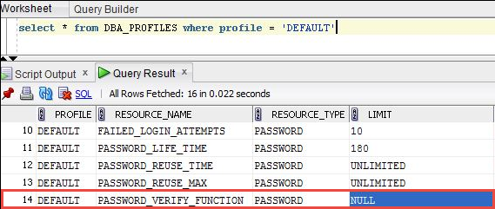

1. Select a DEFAULT profile, and then run the following query:

"Alter profile default limit PASSWORD_VERIFY_FUNCTION PASSWORDCHECK;"

Commit;

*The default profile****Limit****is set to PASSWORDCHECK, indicating that the profile is ready with the password verification.*

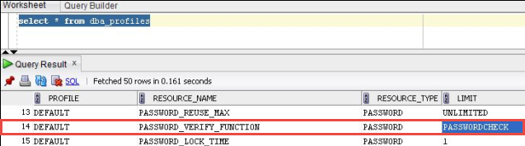

### Add Firewall Exceptions on the Oracle Database Server

Add Exceptions for Programs on the Oracle Database Server

1. In the left panel of the **Windows Firewall with Advanced Security** management console, click**Inbound Rules**.
2. In the **Action**panel on the right, click **New Rule**.

*The****New Inbound Rule Wizard****appears.*

1. On the **Rule Type** page, select **Program**, and then click **Next**.
2. On the **Program**page, select **This program path**.
3. Type the path or browse to a program on the Oracle server, and then click **Next**. See the table below for the list of programs.
4. On the **Action**page, select **Allow the connection**, and then click **Next**.
5. On the **Profile**page, select the needed options for **Domain**, **Private**, and **Public**,as required by your network configuration and allowed by the security policy of your company. Click **Next**.
6. On the **Name**page, type the name for the program exception. Optionally, you can type a description.
7. Click **Finish**.
8. In the center of the **Inbound Rules** panel, verify that the new program exception name appears.
9. Repeat these steps for the remaining programs in the table.

|  |  |
| --- | --- |
| **Program Path and File Name** | **Name** |
| *[Oracle_home]*\bin\oracle.exe | Oracle Database Executable |
| *[Oracle_home]*\bin\tnslsnr.exe | Oracle Listener |
| *[Oracle_home]*\bin\omtsreco.exe | Oracle Services for Microsoft Transaction Server |
| *[Oracle_home]*\jdk\bin\java.exe | Java Virtual Machine |

1.  *[Oracle_home]* is the fully-qualified path name of the Oracle Database Server software.
2. Review [Oracle Database Port Assignments](https://docs.hexagonppm.com/reader/XNI2thZWwpu_8XwBCfLFPQ/XwxQnIRD01lGkbaD9oqTMg) and open ports as required.

### Oracle Database Port Assignments

The Oracle database uses the following port assignments.

 These assignments might not be required if Oracle is not used as a database within your implementation.

 For the Oracle components listed below, port assignments can be custom-configured as indicated. For each component, additional information can be found in the cited Oracle documentation. These Oracle references contain links to additional Oracle content, providing important considerations, including discussions about other affected components that may require matching port changes to be made, as well as the instructions for changing the assigned ports.

|  |  |  |  |
| --- | --- | --- | --- |
| **Port Number** | **TCP/UDP** | **Communication** | **Comments** |
| 80 | TCP | From workstation to server | For Oracle HTTP. Can be reassigned. Configurable port range is 80, 7777-7877, 8888. |
| 1521, 1526 | TCP | From workstation to server; from server to workstation | For Oracle Client SQL Net Connection (1521 is default). Can be changed using Oracle Net Configuration Utility to port within range 1024-65535. |
| 1158 | TCP | From workstation to server | For Oracle Enterprise Console (1158 is default). Configured during database installation. Can be changed within range 5500-5519. |
| 5560, 5580 | TCP | From workstation to server | For Oracle SQL Plus (5560 is default). Can be changed within range 5560-5579. For more information, see the Oracle documentation on database port numbers. |
| 443 | TCP | From workstation to server | For Oracle HTTP Server SSL Port (443 is default). Can be set to either 443 or 4443. For more information, see the Oracle documentation on server port numbers. |
| 7809 | TCP | From server to server | Required for Oracle Global Workshare. GoldenGate is now used for replication and this port is needed for the GoldenGate Manager to handle communication between the servers. |
| 7810-7820 | TCP | From server to server | Required for Oracle Global Workshare. Golden Gate is now used for replication and this port is needed to facilitate the transfer of transaction information between the GoldenGate instances. |